Project Design & Planning: Data Exploration Agent

Version: 1.0
Date: March 9, 2026
Author: Mario Patrick

Project Vision
The Data Exploration Agent aims to democratize data analysis by providing an AI-driven interface where users can interact with datasets using natural language . By eliminating the need for manual chart configuration and technical query expertise, the system reduces the friction between raw data and actionable insights, enabling faster and more accurate decision-making for professionals and analysts alike.

Project Scope

In-Scope
- Natural Language Interface: A text-based input for querying datasets in plain English.
- Automated Data Processing: Ingestion and cleaning of CSV, JSON, and API-connected data via a tiered (Bronze/Silver) architecture.
- AI-Driven Visualizations: Automatic recommendation of chart types (bar, line, scatter, etc.) and mapping of data parameters to axes .
- Responsive Dashboard: A web-based UI built with Vue.js for viewing and interacting with generated charts .
- Backend Integration: A Flask-based server utilizing Langchain for Retrieval-Augmented Generation (RAG).

Out-of-Scope
- Manual Chart Overrides: Users will not manually select axes or chart types, as the system is designed for automation.
- Technical Training: Providing deep training for users on query languages like SQL or Python is outside the project's objectives.

Stakeholder Register
- Non-Technical Professionals (End Users): Primary users who need to interpret data without technical overhead.
- Data Analysts (Super Users): Users who set up datasets, validate AI interpretations, and perform failure investigations.
- System Administrators: Responsible for security, credential management, and maintaining the data retention infrastructure.
- AI Agent (System Actor): The automated backend logic interpreting queries and generating visual instructions.

Project Timeline
Week | Phase | Key Deliverables
Week 1 | Foundation & Ingestion | Environment setup (Vue.js/Flask) and Bronze-to-Silver data pipeline implementation.
Week 2 | AI Core & RAG | Integration of Langchain and development of natural language interpretation logic.
Week 3 | Visuals & Dashboard | Automated chart recommendation engine and responsive dashboard interface.
Week 4 | Security & Deployment | Security hardening, Final QA, and deployment to cloud hosting platform.

Deliverables
Phase | Milestone | Key Deliverables | Estimated Duration
Phase 1 | Foundation | Initial Vue.js frontend and Flask backend setup. | 2 Weeks
Phase 2 | Data Ingestion | Implementation of Bronze and Silver data layers for CSV/JSON. | 3 Weeks
Phase 3 | AI Core | Development of RAG pipeline and Langchain integration. | 4 Weeks
Phase 4 | Visualization | Automatic chart recommendation and dashboard rendering logic . | 3 Weeks
Phase 5 | Security & Scale | Security hardening (GDPR/PCI DSS focus) and database partitioning. | 2 Weeks

Risk Management Plan
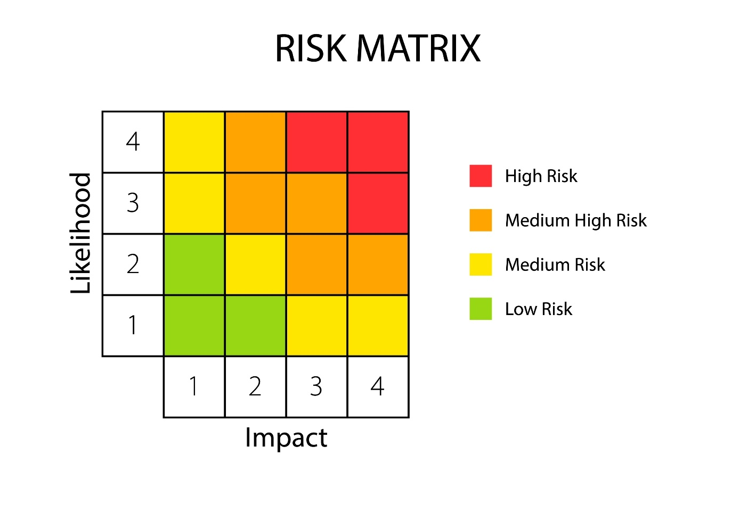

Mitigation Strategy
Risk | Impact | Mitigation Strategy
API Availability | High | Implement retry logic and multi-provider support for AI models.
Data Quality/Formatting | Medium | Establish strict schema validation in the Silver layer and clear user prompts for missing data.
Scalability Bottlenecks | Medium | Utilize B-tree indexing and monthly database partitioning to maintain performance.
Interpretation Errors | High | Log all queries for manual review by Analysts to refine the RAG prompt system.

Work Breakdown Structure (WBS)
- Project Management
  - 1.1 Document Vision and Scope .
  - 1.2 Establish Communication and Risk Plans.
- Environment & Infrastructure
  - 2.1 Setup Vue.js Development Environment.
  - 2.2 Setup Flask Backend with SQL Database.
- Data Management Layer
  - 3.1 Implement Bronze Staging Layer.
  - 3.2 Develop Silver Processing (Clean/Structure) Logic.
- AI & RAG Development
  - 4.1 Integrate AI APIs for initial prototyping.
  - 4.2 Develop structured output using Langchain.
- Visualization Dashboard
  - 5.1 Create Natural Language input interface.
  - 5.2 Build dynamic chart components in Vue.js.
- Quality Assurance & Deployment
  - 6.1 Conduct Failure Investigation tests.
  - 6.2 Implement CI/CD for cloud hosting.

Communication Plan
- Weekly Sprint Review: Analysts and Developers meet to review generated visualizations and refine AI accuracy.
- Monthly Stakeholder Update: Report on project progress, success metrics, and any shifts in scope to the core team.
- Emergency Hotfix Protocol: Direct communication channel for System Administrators to address API outages or security vulnerabilities.
- System Logs & Audit: Automated reporting via the Query_Log to track usage patterns and common interpretation failures.

